**Assignment-9**

**AWT Assignment Date:17/01/2024**

1. Write a java program to creates three push buttons showing three different colors as their label. When a button is clicked, that particular color is set as background color in the frame.

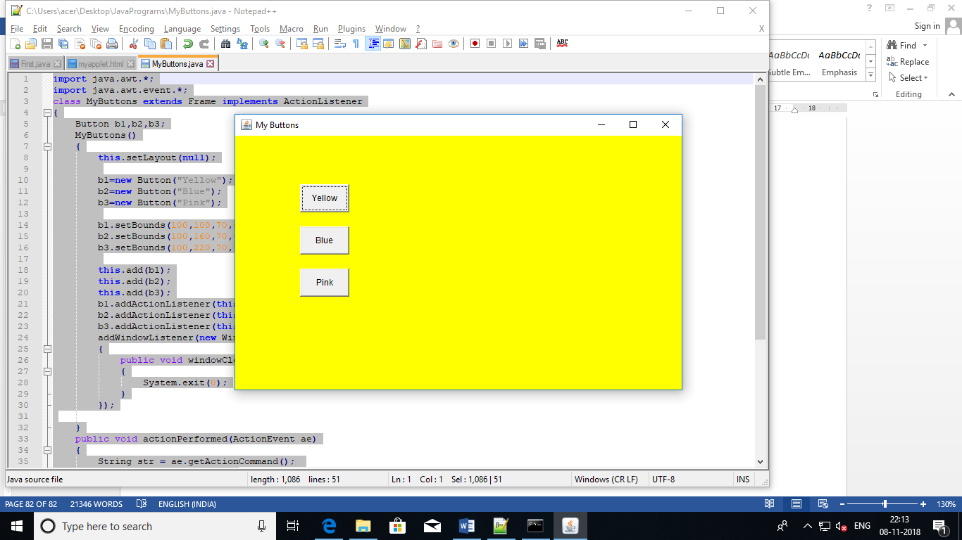

1. Write a java awt program, which will create 3 text field and one button labelled as add. The program will take the input from the two text filed and upon pressing the add button it will display the result in the third text field.

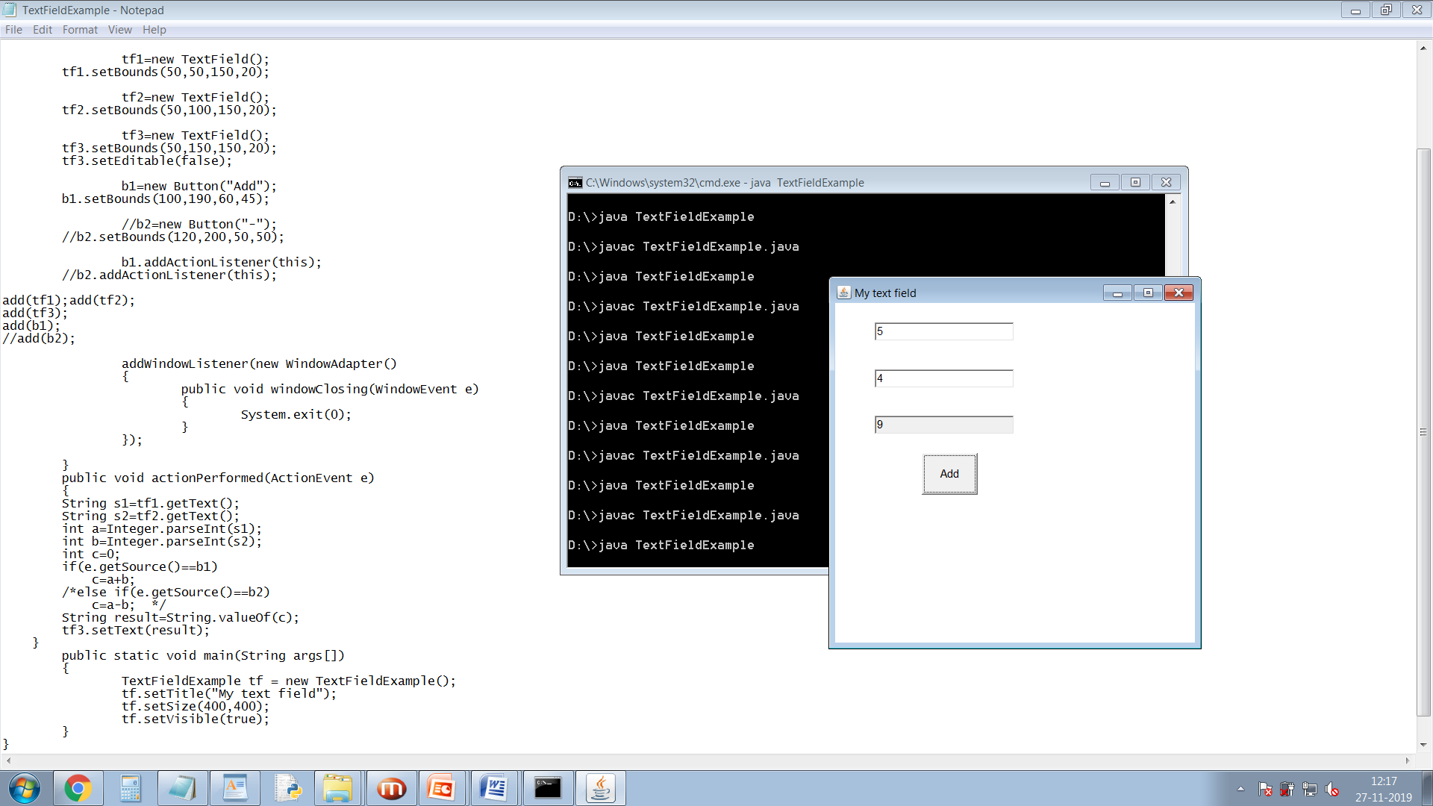

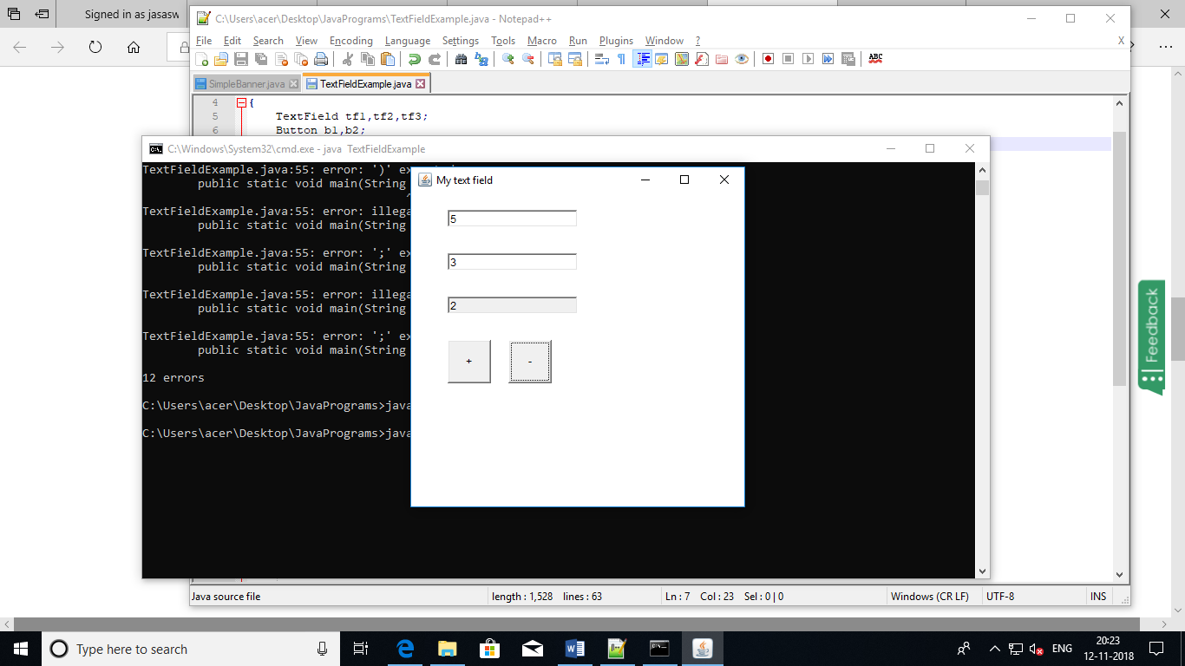

1. Write a java awt program, which will create 2 text field and one button labelled as **Factorial.** The user will enter a number in the 1st text field and upon pressing the button it will display the Factorial of the number in the 2nd text field.

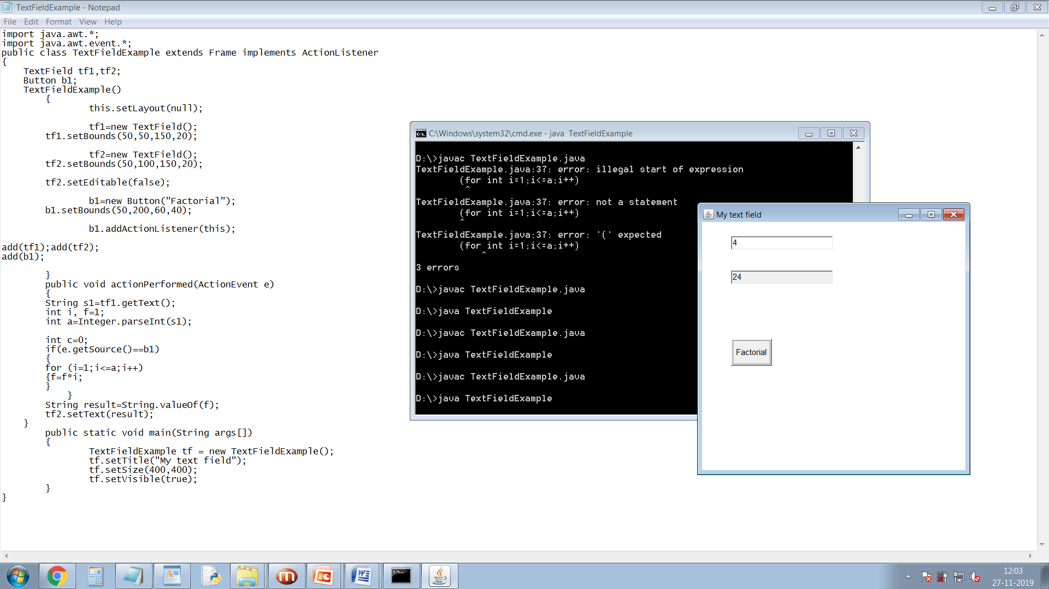

1. Design an AWT GUI application (called AWT Counter). Each time the "Count" button is clicked, the counter value should increase by 1 and each time the Reset button is clicked the counter value should be reset to zero.

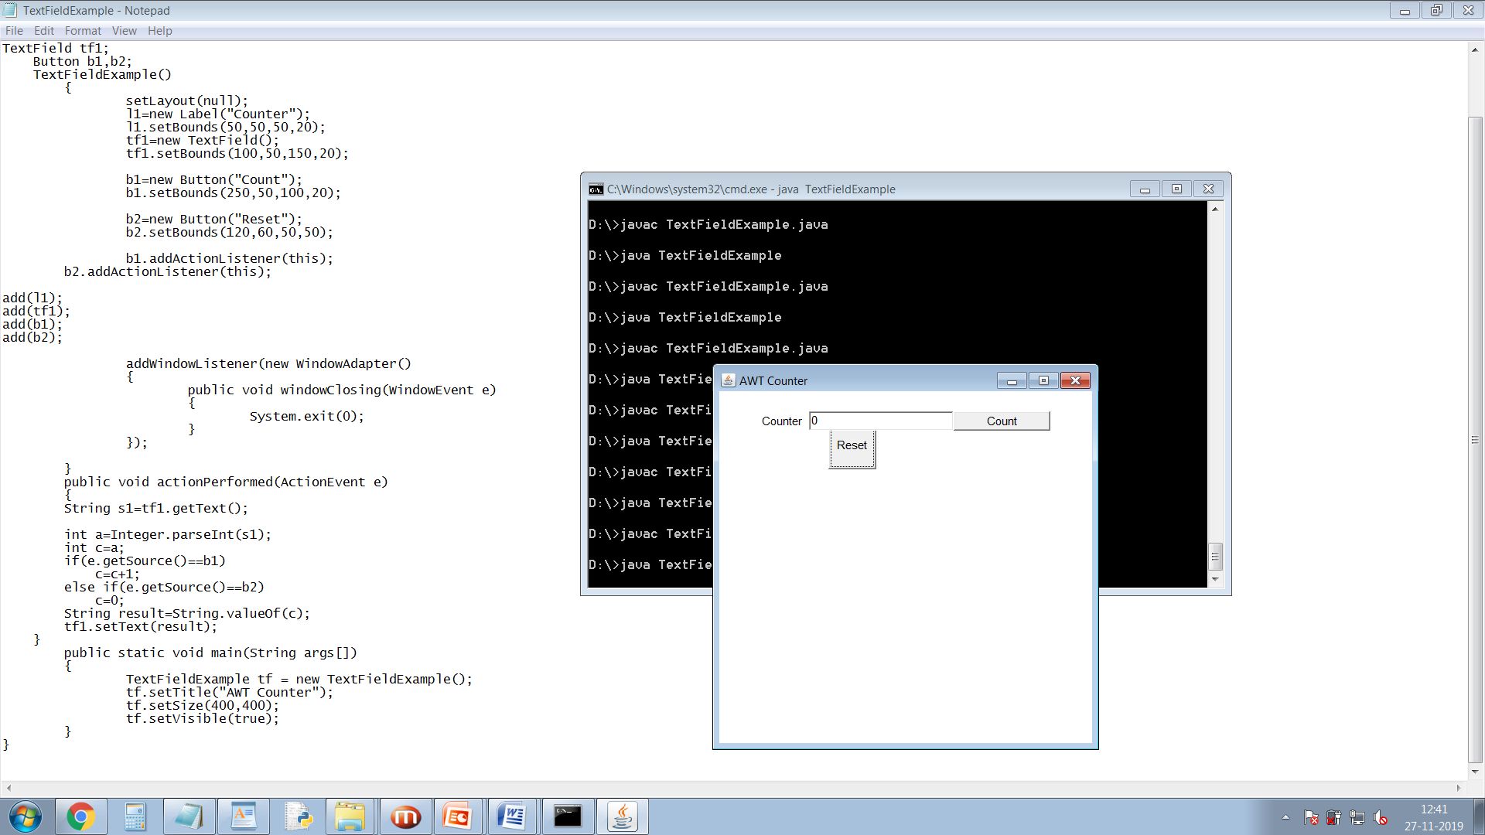

1. Create three color buttons (with caption “Red”, “Blue” and “Green”) and a text label. Initially the text should be displayed in black color. When the user clicks on a particular color button the text should be changed to that particular color as shown in the figure.

